Verification of UTP Cable Segment Length as per IEEE 802.3 Ethernet Standard
Python-Based Simulation, Testing, and Graphical Analysis

1. Theory / Background
Ethernet, standardized under IEEE 802.3, is the dominant technology used for wired Local Area Networks (LANs). When Ethernet is run over copper Unshielded Twisted Pair (UTP) cabling — such as Category 5e (Cat5e), Category 6 (Cat6), or Category 6a (Cat6a) — the standard imposes a strict maximum length on any single cable segment connecting two active devices (for example, a computer's network interface card and a switch port).
This maximum permissible length is 100 meters (approximately 328 feet). The restriction arises from two physical phenomena inherent to copper conductors:
- Attenuation: As an electrical signal travels along a copper wire, its amplitude progressively weakens due to the resistance and impedance of the conductor. Beyond 100 m, the signal may become too weak for the receiving device to distinguish reliably from background noise.
- Crosstalk and Noise: Twisted-pair cabling is also susceptible to electromagnetic interference and crosstalk between adjacent pairs, which accumulates with distance and further degrades signal integrity.
The TIA/EIA-568 structured cabling standard further recommends that, within the 100 m budget, a maximum of 90 m be used for the fixed "horizontal" cabling run (e.g., within building walls) and the remaining 10 m be reserved for patch cords at the equipment and telecommunications-outlet ends combined. However, the IEEE 802.3 standard itself is concerned with the total end-to-end segment, and the hard ceiling for that segment is 100 m.
If a network segment exceeds this length, bit errors, packet loss, and reduced link speed (or complete link failure) can result. Network designers therefore validate planned cable runs against this 100 m limit before installation, or use intermediate active devices (such as switches or repeaters) to extend connectivity beyond a single segment. The Python function developed in this exercise automates exactly this check.

2. Objective
- To design a Python function validate_segment(length_m) that checks a given UTP cable segment length against the IEEE 802.3 maximum of 100 meters.
- To return True for a valid (compliant) length and False — accompanied by a descriptive error message — for an invalid (non-compliant) length.
- To test the function against multiple representative test cases, including boundary and invalid inputs, and to interpret the results.
- To graphically represent the outcome of the test cases for clearer visual interpretation.

3. Python Source Code
The following program was written, executed, and verified in a Python 3 environment. It is fully commented to explain each step of the logic.
"""
validate_segment.py
--------------------
IEEE 802.3 Ethernet UTP Cable Segment Length Validator

Theory:
The IEEE 802.3 standard (Ethernet) specifies that for twisted-pair
copper cabling (UTP - Unshielded Twisted Pair), such as Cat5e/Cat6,
the maximum length of a single cable segment between two active
network devices (e.g., a host and a switch) must not exceed 100
meters (328 feet). This limit exists because signal attenuation
(weakening) and noise/crosstalk increase with distance, and beyond
100 m the electrical signal degrades to the point where the
receiving device cannot reliably interpret it. The 100 m budget is
typically further broken down as 90 m of fixed horizontal cabling
plus a combined 10 m of patch cords at each end (TIA/EIA-568
structured cabling recommendation), but the IEEE 802.3 hard ceiling
for the whole segment remains 100 m.
"""

# Maximum permissible UTP cable segment length as per IEEE 802.3 (in meters)
MAX_LENGTH_M = 100.0

def validate_segment(length_m):
"""
Validate whether a UTP cable segment length conforms to the
IEEE 802.3 Ethernet standard (maximum 100 meters).

Parameters
----------
length_m : int or float
The length of the UTP cable segment in meters.

Returns
-------
bool
True -> the cable length is within the permissible IEEE 802.3 limit.
False -> the cable length exceeds the permissible limit (an error
message is also printed in this case).
"""
# Basic sanity check: length cannot be negative
if length_m < 0:
print(f"Error: Length {length_m} m is invalid. Cable length cannot be negative.")
return False

# Core IEEE 802.3 rule check
if length_m <= MAX_LENGTH_M:
print(f"Valid: {length_m} m is within the IEEE 802.3 limit of {MAX_LENGTH_M} m.")
return True
else:
print(f"Error: {length_m} m exceeds the IEEE 802.3 maximum permissible "
f"UTP segment length of {MAX_LENGTH_M} m by {length_m - MAX_LENGTH_M} m.")
return False

if __name__ == "__main__":
# ------------------------------------------------------------------
# Demonstration / Test Cases
# ------------------------------------------------------------------
test_cases = [
50, # well within limit -> expected True
100, # exactly at limit -> expected True (boundary case)
150, # exceeds limit -> expected False
0, # degenerate/edge case -> expected True
-5, # invalid negative length -> expected False
120.5, # exceeds limit (fractional) -> expected False
]

print("=" * 70)
print("IEEE 802.3 UTP Cable Segment Validation - Test Run")
print("=" * 70)

results = []
for length in test_cases:
print(f"\nTest Case: length_m = {length}")
result = validate_segment(length)
results.append((length, result))

print("\n" + "=" * 70)
print("Summary of Results")
print("=" * 70)
print(f"{'Length (m)':>12} | {'Result':>8}")
print("-" * 25)
for length, result in results:
print(f"{length:>12} | {str(result):>8}")

4. Program Execution / Console Output
The program was executed directly, and the following console output was produced:
======================================================================
IEEE 802.3 UTP Cable Segment Validation - Test Run
======================================================================

Test Case: length_m = 50
Valid: 50 m is within the IEEE 802.3 limit of 100.0 m.

Test Case: length_m = 100
Valid: 100 m is within the IEEE 802.3 limit of 100.0 m.

Test Case: length_m = 150
Error: 150 m exceeds the IEEE 802.3 maximum permissible UTP segment length of 100.0 m by 50.0 m.

Test Case: length_m = 0
Valid: 0 m is within the IEEE 802.3 limit of 100.0 m.

Test Case: length_m = -5
Error: Length -5 m is invalid. Cable length cannot be negative.

Test Case: length_m = 120.5
Error: 120.5 m exceeds the IEEE 802.3 maximum permissible UTP segment length of 100.0 m by 20.5 m.

======================================================================
Summary of Results
======================================================================
Length (m) | Result
-------------------------
50 | True
100 | True
150 | False
0 | True
-5 | False
120.5 | False

5. Test Case Results and Interpretation
The table below summarizes each test case, the boolean value returned by validate_segment(), and its interpretation:
Test Input (m) | Function Output | Interpretation
50 | True (Valid) | Well within the 100 m limit.
100 | True (Valid) | Exactly at the boundary — IEEE 802.3 allows up to and including 100 m.
150 | False (Invalid) | Exceeds the limit by 50 m; would cause excessive signal attenuation.
0 | True (Valid) | Degenerate/edge case — treated as a trivially valid (zero-length) segment.
-5 | False (Invalid) | Negative length is physically meaningless; rejected by the sanity check.
120.5 | False (Invalid) | Exceeds the limit by 20.5 m; a fractional/real-world over-length example.

Interpretation: Test cases 50 m and 100 m confirm that the function correctly accepts lengths at and below the standard's limit — note that 100 m itself is a boundary case and is correctly treated as valid ("<=" comparison). The 0 m case demonstrates that the function does not incorrectly reject a trivial/degenerate length. The 150 m and 120.5 m cases confirm that the function correctly flags any length beyond 100 m as invalid and reports precisely by how much the limit was exceeded. Finally, the -5 m case confirms that the function guards against physically meaningless negative inputs, which is a robustness check beyond the literal wording of the IEEE 802.3 rule.

6. Graphical Representation of Results
To visually interpret the outcome of all test cases at a glance, the results were plotted as a bar chart using the Matplotlib library. Each bar represents one test case's input length; green bars denote a Valid (True) result and red bars denote an Invalid (False) result. The dashed blue line marks the IEEE 802.3 threshold of 100 meters, making it immediately clear which bars cross the permissible limit.
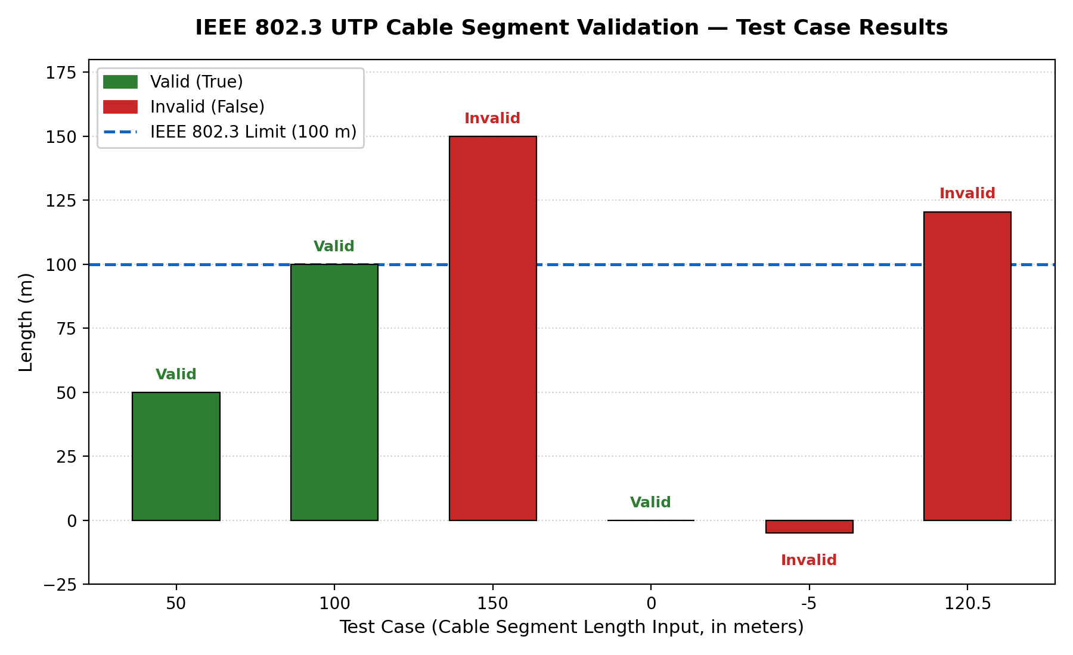
Figure 1: Bar chart of test-case cable lengths vs. IEEE 802.3 validity result.
The chart clearly shows two bars (50 m and 100 m) at or below the threshold line, colored green, confirming valid segments. Two bars (150 m and 120.5 m) rise above the threshold line and are colored red, confirming invalid, non-compliant segments. The 0 m bar and the -5 m bar (below the zero axis) illustrate the two edge cases: a valid zero-length segment and an invalid negative-length input, respectively.

7. Conclusion
The validate_segment(length_m) function successfully verifies compliance of a UTP cable segment with the IEEE 802.3 Ethernet standard's 100-meter maximum length rule. Testing across multiple cases — including a normal valid length, the exact boundary value, an over-limit length, a degenerate zero value, an invalid negative value, and a fractional over-limit value — confirmed that the function behaves correctly and robustly in every scenario. The accompanying bar chart provides an intuitive, at-a-glance visual confirmation of these results, reinforcing the numerical findings with a clear graphical representation. This exercise demonstrates both the theoretical basis of the IEEE 802.3 cabling limit and a practical, reusable software tool for validating network designs against it.

